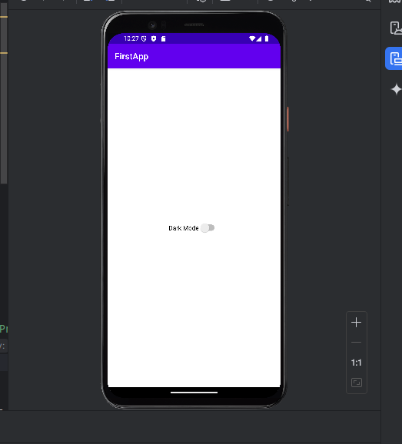

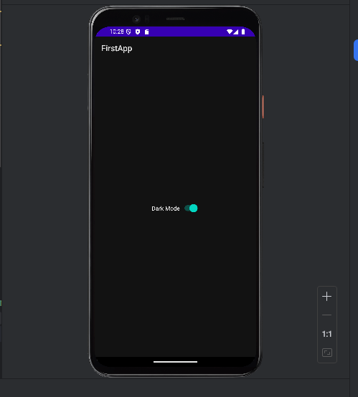

JAVA

package com.example.firstapp;  
  
import android.content.Intent;  
import android.content.SharedPreferences;  
import android.os.Bundle;  
import android.view.View;  
import android.widget.Button;  
import android.widget.CompoundButton;  
import android.widget.EditText;  
import android.widget.Switch;  
import android.widget.TextView;  
  
import androidx.activity.EdgeToEdge;  
import androidx.appcompat.app.AppCompatActivity;  
import androidx.appcompat.app.AppCompatDelegate;  
import androidx.core.graphics.Insets;  
import androidx.core.view.ViewCompat;  
import androidx.core.view.WindowInsetsCompat;  
  
public class MainActivity extends AppCompatActivity {  
  
 private Switch themeSwitch;  
 private SharedPreferences sharedPreferences;  
  
 @Override  
 protected void onCreate(Bundle savedInstanceState) {  
 super.onCreate(savedInstanceState);  
 setContentView(R.layout.*activity_main*);  
  
   
 themeSwitch = findViewById(R.id.*themeSwitch*);  
  
   
 sharedPreferences = getSharedPreferences("ThemePrefs", *MODE_PRIVATE*);  
 boolean isDarkMode = sharedPreferences.getBoolean("isDarkMode", false);  
  
   
 if (isDarkMode) {  
 AppCompatDelegate.*setDefaultNightMode*(AppCompatDelegate.*MODE_NIGHT_YES*);  
 themeSwitch.setChecked(true);  
 } else {  
 AppCompatDelegate.*setDefaultNightMode*(AppCompatDelegate.*MODE_NIGHT_NO*);  
 themeSwitch.setChecked(false);  
 }  
  
   
 themeSwitch.setOnCheckedChangeListener(new CompoundButton.OnCheckedChangeListener() {  
 @Override  
 public void onCheckedChanged(CompoundButton buttonView, boolean isChecked) {  
   
 SharedPreferences.Editor editor = sharedPreferences.edit();  
 editor.putBoolean("isDarkMode", isChecked);  
 editor.apply();  
  
   
 if (isChecked) {  
 AppCompatDelegate.*setDefaultNightMode*(AppCompatDelegate.*MODE_NIGHT_YES*);  
 } else {  
 AppCompatDelegate.*setDefaultNightMode*(AppCompatDelegate.*MODE_NIGHT_NO*);  
 }  
 }  
 });  
 }  
}

XML

<?xml version="1.0" encoding="utf-8"?>  
<LinearLayout xmlns:android="http://schemas.android.com/apk/res/android"  
 xmlns:app="http://schemas.android.com/apk/res-auto"  
 xmlns:tools="http://schemas.android.com/tools"  
 android:layout_width="match_parent"  
 android:layout_height="match_parent"  
 android:orientation="vertical"  
 android:gravity="center"  
 tools:context=".MainActivity">  
  
 <Switch  
 android:id="@+id/themeSwitch"  
 android:layout_width="wrap_content"  
 android:layout_height="wrap_content"  
 android:layout_centerInParent="true"  
 android:text="Dark Mode" />  
  
</LinearLayout>